# Bzip2 prefetch behavior on the x86 Haswell Machine

## Measure (in one command) bzip using the following events: L2_RQSTS:ALL_DEMAND_REFERENCES (r53e724:u) which is total L2 cache accesses, L2_RQSTS:DEMAND_DATA_RD_MISS (r532124:u) which is total L2 cache misses, and L2_RQSTS:ALL_PF (r53f824:u) which is total prefetches from the L2 cache.

Performance counter stats for '/opt/ece571/401.bzip2/bzip2 -k -f ./input.source':

285,465,711 r53e724:u

89,708,536 r532124:u

103,968,466 r53f824:u

3.497639326 seconds time elapsed

Calculate the L2 cache miss rate from the first two results, also note the total time.

Miss rate: 89708536/285465711=31.4%

Total time 3.5s

# Software Prefetching and bzip2 on Haswell

## Re-run the previous prefetch results on Haswell, but instead of running bzip2 run bzip2.swprefetch which was compiled with -fprefetch-loop-arrays which enables sw prefetch instructions. Record the miss rate and total time.

Performance counter stats for '/opt/ece571/401.bzip2/bzip2.swprefetch -k -f ./input.source':

249,302,035 r53e724:u

83,226,431 r532124:u

165,070,103 r53f824:u

3.412034034 seconds time elapsed

Miss rate: 83226431/249302035=33.38%

Time: 3.4s

# equake_l prefetch behavior on the x86 Haswell Machine

## Calculate the L2 cache miss rate from the first two results, also note the total time.

Performance counter stats for '/opt/ece571/equake_l.specomp/equake_l':

13,541,781,336 r53e724:u

2,051,705,195 r532124:u

37,254,617,844 r53f824:u

134.519077680 seconds time elapsed

Cache miss= 2051705195/13541781336=15.15%

Total time : 134s

# equake_l software prefetch behavior on the x86 Haswell Machine

## Calculate the L2 cache miss rate from the first two results, also note the total time.

Performance counter stats for '/opt/ece571/equake_l.specomp/equake_l.swprefetch':

14,842,463,217 r53e724:u

2,449,174,747 r532124:u

37,714,660,121 r53f824:u

145.028718323 seconds time elapsed

Miss rate=2449174747/14842463217=16.5%

Total time 145s

# Hardware Prefetch Disabled

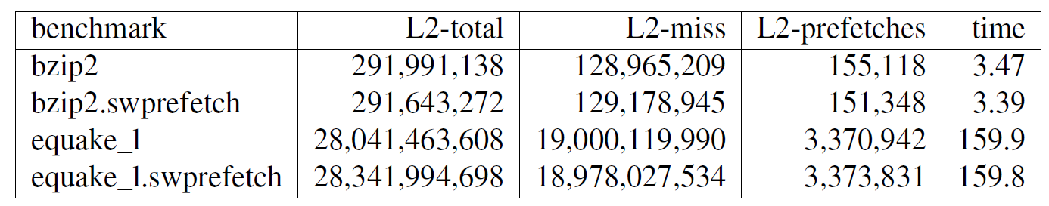

# Short Answer Questions

## Did enabling software prefetch help on bzip2? (i.e. the results in question 1 and question 2?)

No the miss rate has increased when the software prefetch is on.

## Did enabling software prefetch help on equake_l? (i.e. the results in question 3 and question 4?)

No, the miss rate has increased when the software prefetch is on.

## How did turning off the prefetcher affect the bzip2 results (i.e. question 1 vs question 5?)

Hardware prefetch diabled bzip2 L2 miss rate=44.16% time:3.47s

Prefetch 31.4% time 3.5s.

Turning off the hardware prefetch will increase the miss rate a lot.

## How did turning off the prefetcher affect the equake_l results (i.e. question 3 vs question 5?)

Hardware prefetch diabled equake_l L2 miss rate=67.76% time 159.9s

Prefetch equake_l miss rate=15.15% time 134s

Disabling the hardware prefetcher has greatly increase the miss rate and time.

## With the hardware prefetcher disabled, did enabling software prefetch help at all? (question 5)

Bzipswprefetch miss rate=129178945/291643272=44.29%

Equake_lswprefetch miss rate=66.96%

The bzip and equake_l do not change lot for the miss rate.

## Why do you think the software prefetch performance is so underwhelming?

I think the bzip2 and equake_l does not have a lot improvement that can be done by the software prefetch. It’s just how the software is written to be not so much room improvement for the software prefetches.